TECHNICAL REPORT ON STUDENT INDUSTRIAL WORK EXPERIENCE SCHEME (SIWES)

AT
PHYSICAL PLANNING, FEDERAL POLYTECHNIC,
MUBI, ADAMAWA STATE

FROM: 6TH OCTOBER, 2024
TO: 29TH JANUARY, 2025

TITLE PAGE

BY
ABUBAKAR NASIRU
(SE/ARC/ND/23/013)

SUBMITTED TO THE DEPARTMENT OF ARCHITECTURAL TECHNOLOGY, FEDERAL POLYTECHNIC MUBI, IN PARTIAL FULFILLMENT OF THE REQUIREMENT FOR THE AWARD OF NATIONAL DIPLOMA (ND) IN ARCHITECTURAL TECHNOLOGY

JULY, 2025

DECLARATION
This is to declare that I, ABUBAKAR NASIRU with registration number SE/ARC/ND/23/013 undertook my four months SIWES at PHYSICAL PLANNING, FEDERAL POLYTECHNIC, MUBI, ADAMAWA STATE and have acquired all the experience compiled in this report in the course of my SIWES.

……………………………….. ……………………………
ABUBAKAR NASIRU Sign/Date

CERTIFICATION
This is to certify that this report compiled by ABUBAKAR NASIRU (SE/ARC/ND/23/013) meets the requirement of governing the award of National Diploma (ND) of the Federal Polytechnic Mubi, and is approved by:

………………………………. ……………………
Name of Supervisor Date
Departmental Supervisor

………………………………. ……………………
Arc. Daniel Barka Date
Departmental SIWES Coordinator

…………………………………. ……………………
Arc. Mohammed Usman Date
Head of Department

DEDICATION
I dedicate this technical report to my parents, my sisters and colleagues and to all those that supported me throughout the industrial training.

ACKNOWLEDGEMENTS
First of all, my sincere appreciation goes to Almighty God for his guidance and protection throughout my industrial training.
I wish to thank all staff of Architectural Technology department in Federal Polytechnic, Mubi.
My appreciation goes to my beloved parent for the motivation, prayers and financial support towards my SIWES exercise.
My special thanks go to my beloved brothers and sisters for all their care and support throughout my industrial training.
I want to also thank my colleagues and others; I really appreciate your efforts.

TABLE OF CONTENTS
TITLE PAGE i
DECLARATION ii
CERTIFICATION iii
DEDICATION iv
ACKNOWLEDGEMENTS v
TABLE OF CONTENTS vi
ABSTRACT vii
CHAPTER ONE 1
INTRODUCTION 1
1.1 Aim and objective of SIWES 1
1.2 Brief history of SIWES and ITF in Nigeria 2
1.3 Significance of SIWES to students 2
CHAPTER TWO 4
2.1 Brief history of Physical Planning, Federal Polytechnic, Mubi 4
2.2 Company organogram 5
CHAPTER THREE 1
DESCRIPTION OF WORK EXPERIENCE 1
3.1 Site clearance 1
3.2 Setting out 1
3.3 Excavation of foundation 2
3.4 DPC and DPM construction 5
3.5 Block work 6
3.6 Lintel construction 8
CHAPTER FOUR 11
SUMMARY, CONCLUSION AND RECOMMENDATIONS 11
4.1 Challenges encountered during siwes 11
4.2 Summary 11
4.3 Conclusion 12
4.4 Recommendations 12
REFERENCES 13

ABSTRACT
The report summarises the result of work done during my SIWES experience, the technical report consists of four chapters, which comprises of introduction, history and criteria’s of SIWES in chapter one followed by their aims and objectives, historical background, organizational structure of the organization in chapter two, while chapter three consist of the work actually carried out during the SIWES programme and lastly chapter four consist of the summary, conclusions and recommendation.

CHAPTER ONE

1.0 INTRODUCTION
The acronym (SIWES) meaning “Student Industrial Work Experience Scheme” is a skill training designed to expose and prepare student in institution of higher for industrial working situation they may likely meet after graduation. The scheme is meant to train student on the method of work and the experience needed in handling the equipment and machines may not to be available in their institution. The scheme is financed by the Federal Government and operators through Industrial Training Fund (ITF), Ogwo, (2001) and operates with National University Commission (NUC), National Board of Technical Education (NBTE), and National Commission for College of Education (NCCE) and industries. However, SIWES also expose the student to many practical works which the institution did not treat in details without plastering what the institution taught theoretically into practical. A point from academic obtained. SIWES assist the student to understand the nature of his/her work in future.

1.1 Aim and objective of SIWES
ITF initiates SIWES with the sole aim of: Exposing student with the practical experience related to the theoretical knowledge acquired in school. Bridging the gap between theoretical learning and practical work situation.
- To make industries/organization to have confidence in the abilities and capacities of the graduates. SIWES helps the industries to evaluate the prospective employees and give feedback to the institution.
- It helps the student to gain work and also have experience and confidence as a result if successful completion of a given job assigned to them.
- To enlist and strengthen the employers’ involvement in the institution activities and in the entire educational process of preparing the student for meaningful and productive employment into industries.
- It provides an avenue for student in the Nigerian University and Polytechnics to acquire industrial skill and experience in their course of study.
- Development for greater understanding in other people and proffers skills in human relations.

1.2 Brief history of SIWES and ITF in Nigeria
It was said by Dr. Azikiwe Nnamdi, the one president of Nigeria that the practice of work but they all have the same goal that they all want to achieve in countries like china. They established within the premises of institution to provide real life situation, lack of practical skill of locally trained engineers and technologies. the chine way and condition of SIWES is that all institution must give student real life working experience in industrial works. Lecturers are involved in the industrial activities rendering constant services. So, all these countries have their own way of conducting the scheme but all lye on the same goal. And in Nigeria, the history of SIWES can be traced by the history of IITF which is the backbone of SIWES. ITF was established in 1974 under degree of 47 of 1971. It was a body established by the Federal Government of Nigeria and was given responsibility of training indigenous Nigerians. The establishment of the body became necessary due to high demand of Nigeria to take up the vacant positions created in various sector of the economy after the colonial masters have departed. Therefore, the Federal Government discovered that it is easier to train students that are skilled in school to be trained and meet up with gaps in the Nigerian economy and a scheme was established to care for such training and it was named Student Industrial Work Experience Scheme (SIWES). In 1973, the national board of technical education (NBTE) made it compulsory for all the polytechnic students, be it federal or state.

1.3 Significance of SIWES to students
Principles taught in the classroom are vein forced given concrete applications on the industrial assignment and students is able to see the relevance of their students which increase their motivation. It helps in given students the knowledge on the types of work to do after his/her graduation. SIWES given students opportunity for a change of environment as they move their institution to the place of attachment which changes the routine types of environment to a word of work. It helps in connecting the institution and the industrial their relationship the introduction of SIWES.

CHAPTER TWO

2.1 BRIEF HISTORY OF PHYSICAL PLANNING, FEDERAL POLYTECHNIC, MUBI, ADAMAWA STATE
The Physical Planning Directorate, Federal Polytechnic, Mubi, Adamawa State, was established in the year 2009, with the sole aim of planning, design, construction and supervision of new project in the Federal Polytechnic, Mubi be it in contract or direct labour. And procurement and preparation of land document.
The following are some units in the Physical Planning Directorate, Federal Polytechnic, Mubi;
Architecture: Responsible for design and supervision of construction works in the Polytechnic.
Civil Engineering: Responsible for the supervision of construction of structural element during construction.
Building Tech: Responsible for supervision and quality control.
Town planning: Planning and maintaining the layout plan of the polytechnic.
Quantity surveyor: Participates in tendering, preparation of contract document, valuation etc.
Craft men: Assist the professional in carrying out their duties
Admin: The Administrative staff supports all the staff in the directorate.

2.2 COMPANY ORGANOGRAM
DIRECTOR OF WORKS
TOWN PLANNERS
PRINCIPAL TOWN PLANNERS
ARCHITECTS
ADMIN
ENGINEERS
ASST. CHIEF TECH OFFICER
CHIEF ARCHITECT
BUILDING ENGINEER
CIVIL ENGINEER
PRINCIPAL BUILDING ENGR..
ASST. CHIEF TECH OFFICER

FOREMAN
FINANCIAL TECHNICIAN
PRINCIPAL TOWN PLANNERS
ASST. CHIEF TECH OFFICER

PRINCIPAL EXECUTIVE OFFICER
HIGHER EXECUTIVE OFFICER

CONFIDENTIAL SECRETARY
CLERK
LAB ATTENDANT

Figure 2.1: Organogram

CHAPTER THREE

DESCRIPTION OF WORK EXPERIENCE

3.1 SITE CLEARANCE
Before the excavation of the proposed foundation commences, we cleared the site. So therefore, site clearance is the removal of all accumulated waste from an area to ensure that it is free from any environmental hazard, obstacle or unsightly mess.

3.2 SETTING OUT
Square method was used for the setting out, as observed after 90 from all angles using the pages ropes string and also from the plan. Setting out is done with high degree of accuracy or else the building will not last as the engineer answered to my question “why are some calculations made during setting out”.
The method of the setting out used at the site is the builder’s square method
Procedure for the builder’s square method of the setting out:
- After site clearance material to be used were made available at the site.
- Proper site measurement was taken and all angles of the site were noted.
- Lines and blocks to be used were made available.
- Builder’s square was used to align the blocks and a line was used to extend the alignment to another angle of the site as specified in the floor plan, this was done continuously.
- The same method was applied to obtain all the angles of the building, by using this procedure demarcation, foundation boundary was made which brings about the starting point of excavation.
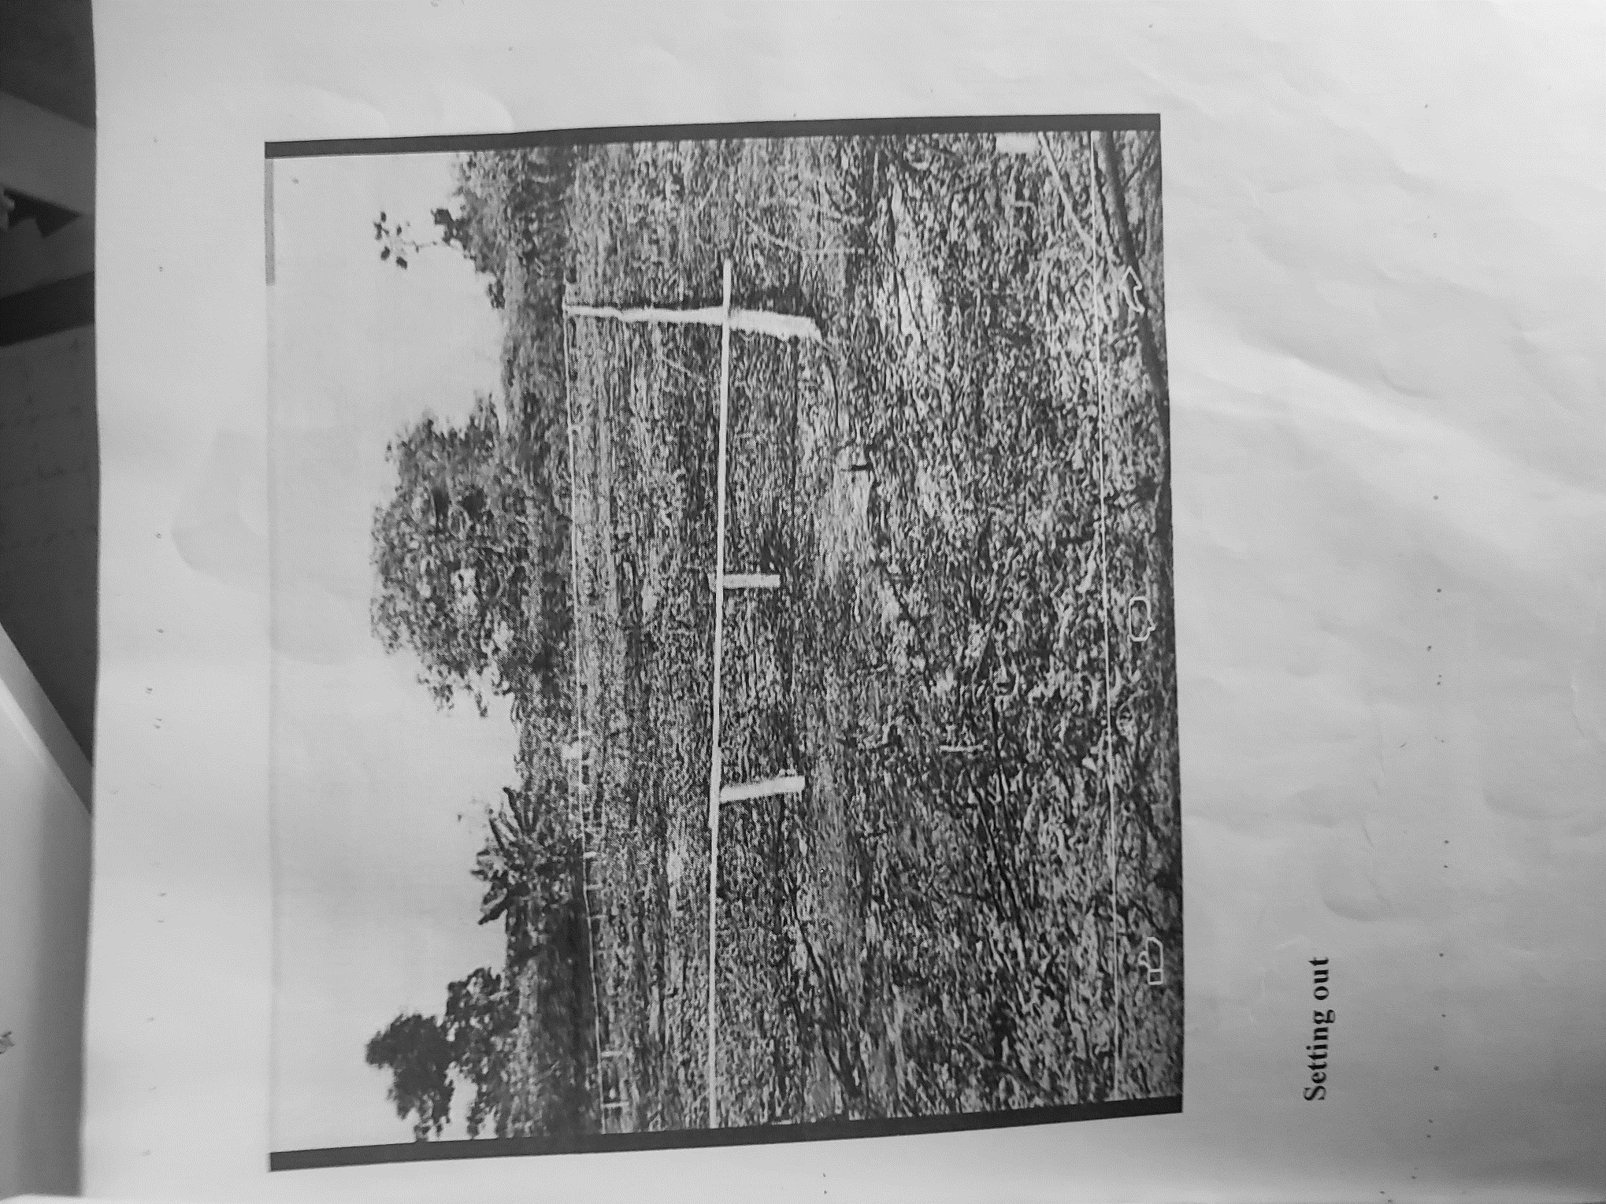
Plate 3.1: Setting out using profile board
Source: Author’s work, 2025

3.3 EXCAVATION OF FOUNDATION
Excavation can be defined as the process of digging a soil surface or trench for foundation lay into trench.
It is also the process of removing top soil for foundation trenches. Excavation work is an important part of building operation that commences immediately after setting out the width of excavation for foundation trenches is marked out on the profile and then transferred to the ground. Excavation must be carried out carefully to ensure safety of workers.
Excavation can be done using two methods mechanical and manual. In small construction we normally use manual method while in large construction we use mechanical e.g. like road construction.
Excavation work were carried out manually where unskilled labourer where involved with digger, shovels, head pan and wheel barrow. The following factors must be considered when carrying out any excavation work.
- Nature of the soil
- The width and depth of foundation
- Climatic condition at the time of excavation
- The water table of the soil
- The period excavation work is expected to be left open.
- The effect of excavation on existing adjacent structure.
As the engineer and the former goes to set basket, I was keeping an eye on how the beams were set. When digging the basket some places were 1.2 while some other places were 1.4 by 1.4 because of the type of soil on the site. When putting the basket in a poor soil, cement and sharp sand is mixed out before putting the basket to avoid rusting.

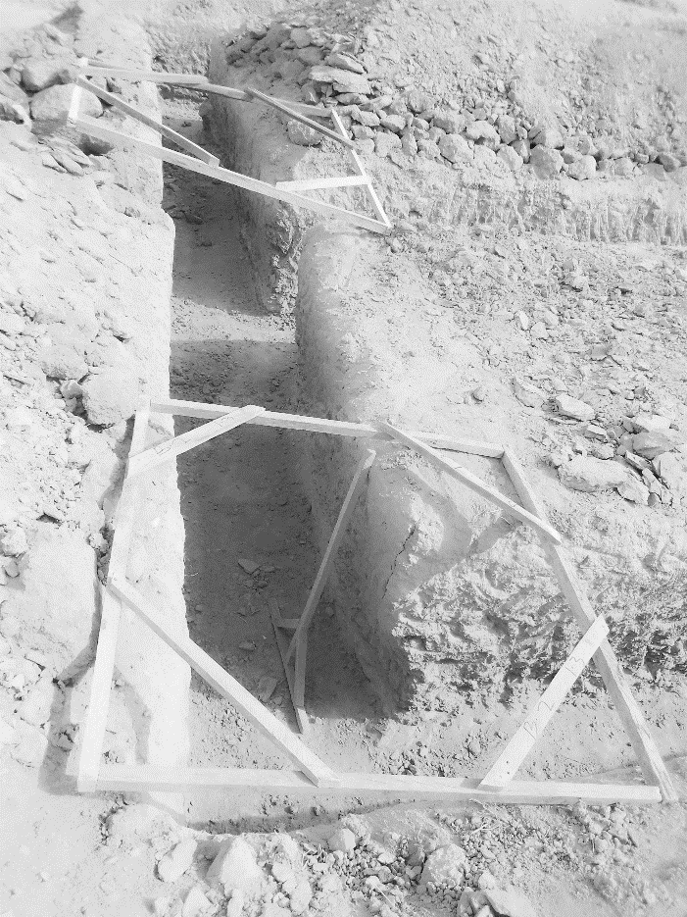
Plate 3.4: Excavation
Source: Author’s work, 2024
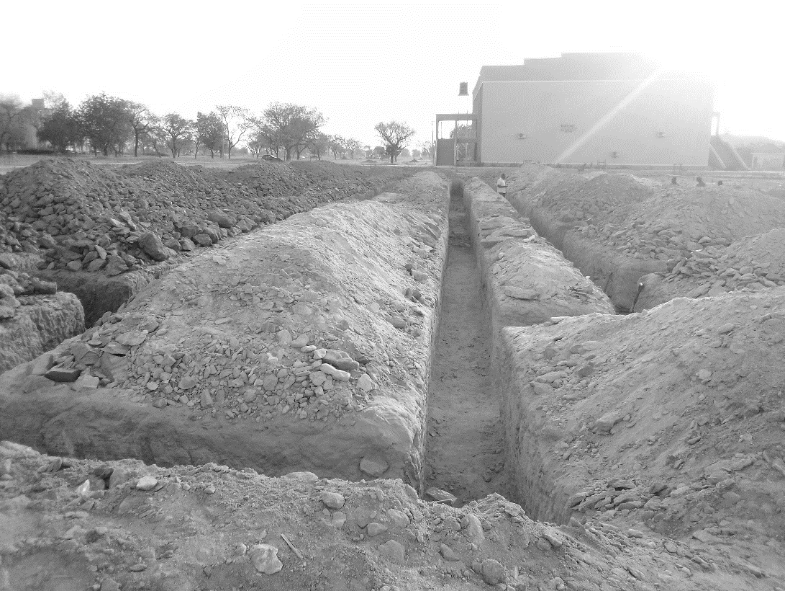

Plate 3.5: Excavation
Source: Author’s work, 2024

3.4 DPC AND DPM CONSTRUCTION
Following the completion of foundation filling and compaction, I was involved in the installation of the Damp Proof Course (DPC) and Damp-Proof Membrane (DPM) to prevent moisture from rising into the building structure.
The DPC, which is typically a layer of waterproof material (such as thick plastic sheeting or bituminous felt), was laid horizontally on top of the blockwork at the base of the walls. This layer served as a barrier to stop ground moisture from seeping upward into the walls, which could otherwise lead to dampness and long-term damage. We made sure that the surface was clean and level before placing the DPC to ensure full coverage and effectiveness.
Right after laying the DPC, we also applied the Damp Proof Membrane (DPM) over the compacted sand and hardcore surface of the floor area. The DPM, which is a durable polythene sheet, was carefully spread out across the foundation floor and extended slightly up the sides to overlap with the DPC. This was done to create a continuous moisture barrier. We ensured there were no punctures or tears, and where necessary, joints were overlapped and sealed with waterproof tape.
The engineer on site emphasized the importance of both DPC and DPM in preventing moisture ingress, which could lead to mold, deterioration of materials, and an unhealthy living environment. Being part of this process gave me a better understanding of how critical these protective layers are in maintaining the integrity and lifespan of a building.

3.5 BLOCK WORK
Blocks were molded in a number of sizes, various compositions, strengths, and shapes such as 9 inches and 6 inches. The 9-inch blocks were used for external walls, while the 6-inch ones were for internal walls. After the foundation work was finished, the blockwork was built to cover the spaces as well. All the blockwork did not carry any load; they were erected to cover spaces and also act as partition walls.
Procedure
- Before starting the block laying process, the site was prepared by clearing debris and ensuring a level foundation.
- The layout of the walls or structure was marked using chalk lines or strings to guide the placement of the blocks.
- Blocks or bricks were selected based on the desired strength, size, and aesthetic requirements of the project.
- Mortar was mixed according to the specifications, typically using a combination of cement, sand, and water.
- A layer of mortar was spread evenly along the foundation where the first course of blocks would be placed.
- A level was used to check the horizontal and vertical alignment of the blocks.
- Once the first course was laid, additional courses of blocks were added on top, following the same process.
- Each block was buttered with mortar on its ends before being placed to ensure a strong bond between the blocks.
- Blocks may have needed to be cut to fit around corners, openings for doors or windows, or to maintain the desired pattern.
- Excess mortar was scraped off the joints using a trowel, and any gaps or voids were filled to create a smooth, uniform surface.
- Once the block laying was complete, the work area was cleaned up, and any excess materials or debris were removed from the site.

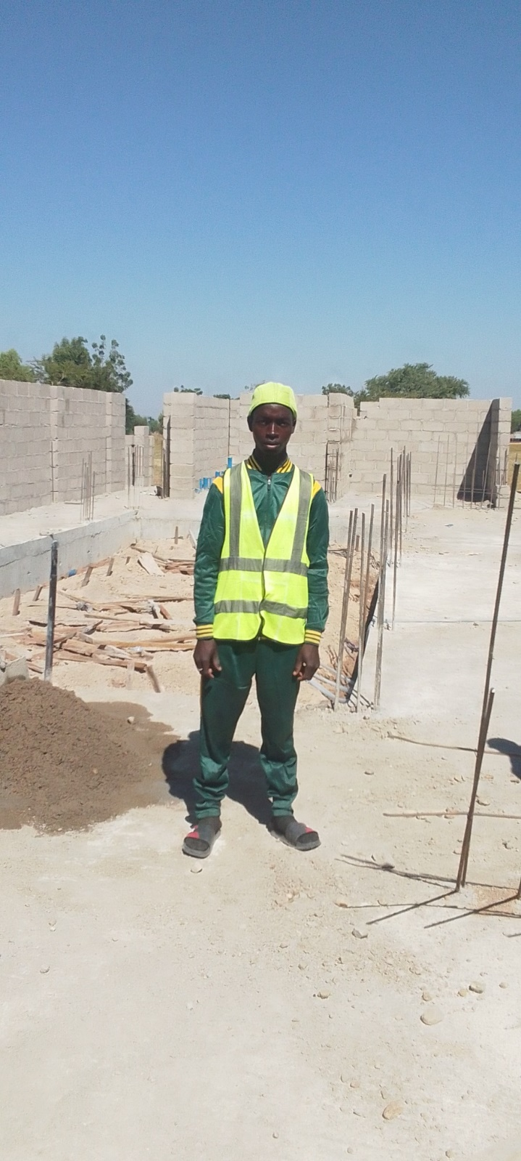
Plate 3.2: Block work
Source: Author’s work, 2025
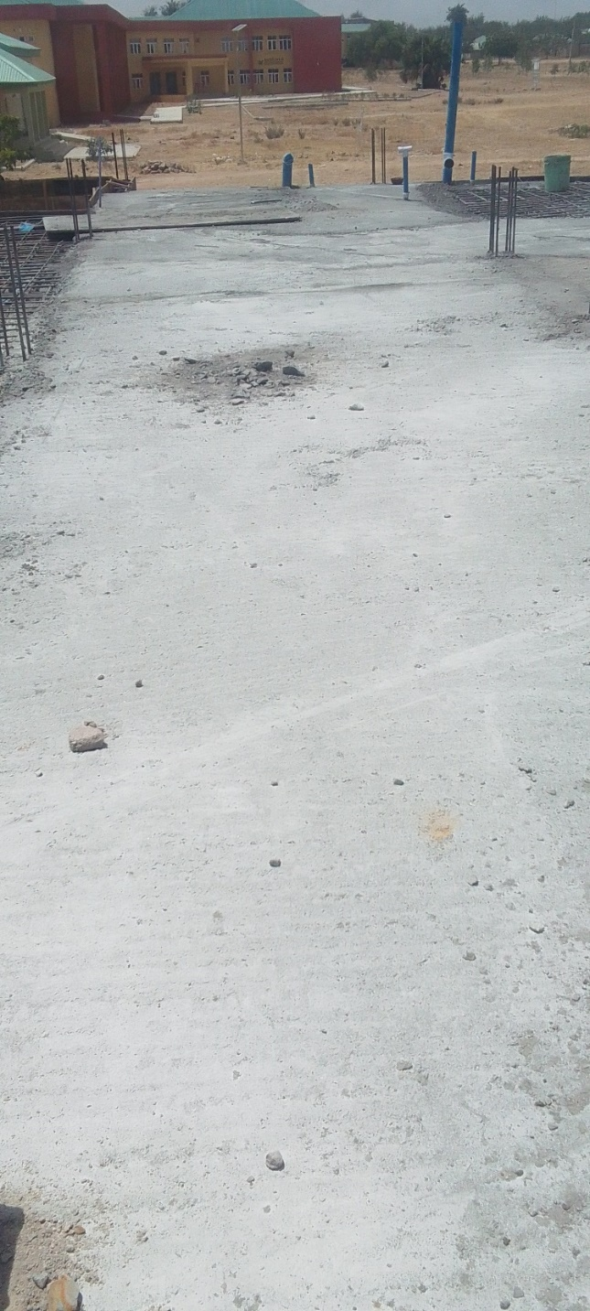
Plate 3.3: DPM and DPC construction
Source: Author’s work, 2025

3.6 LINTEL CONSTRUCTION
After completing the blockwork up to the required height for doors and windows, we proceeded with the construction of lintels—a critical phase in providing structural support above all openings. The process began with the marking and measurement of all door and window openings to determine the exact length of each lintel. Once the dimensions were confirmed, the carpenters constructed the formwork (shuttering) for the lintels using strong timber, ensuring it was firmly braced and properly aligned.
Next, we tied the reinforcement bars according to the structural drawings. These bars were essential for strengthening the lintel and distributing the load above the openings. Spacers were used to maintain cover between the reinforcement and the formwork, which helps protect the steel from corrosion. Once the reinforcement was fixed and inspected by the engineer, we proceeded to pour concrete into the lintel formwork. The concrete mix was properly proportioned and vibrated to remove air pockets and ensure proper bonding and compaction. The top of the lintel was leveled and finished neatly using a trowel. After pouring, the lintels were left to cure and gain strength, and we kept the surface moist regularly to aid the curing process. The formwork was not removed until the concrete had fully set and reached the required strength, usually after 7 to 14 days. This stage was particularly important as the lintels help in transferring the loads from above openings to the supporting walls on both sides. Being part of this process helped me understand the importance of accuracy, proper formwork, and reinforcement placement in lintel construction.

3.7 PLASTERING OF WALL
Plaster is a thin layer of mortar applied over the masonry surface and it acts as a damp-proof coat over the masonry work. Plastering also provides a finished surface over the masonry that is firm and smooth hence it enhances the appearance of the building.
Tools for plastering
- Plastering trowel - choose a stainless-steel trowel with a comfortable, evenly weighted handle.
- A plasterer’s hawk board - this is the tool that holds your plaster. A plastic hawk board is lighter than a wooden one, although both types are absolutely fine. A wooden hawk board will last much longer though.
- Bucket trowel - this tool is specially designed to make it easy to scoop plaster from the bucket to your hawk board.
- A power mixer - although it’s fine to mix the plaster by hand, using a power mixer is much easier and quicker. It’s especially suitable if you’re creating large batches of plaster which need to be applied quickly.
- A good quality paint brush - this is essential for keeping your edges clean and applying water to your plaster.
Procedure
- Prepared the Wall: Ensured the wall surface was clean, dry, and free from dust, dirt, and loose debris. Repaired any cracks or defects in the wall by filling them with patching compound or plaster.
- Prepared the Plaster Mix: Mixed the plaster by combining the appropriate ratio of cement and sand in a clean bucket.
- Wetted the Wall: Dampened the wall with water using a brush or spray bottle to prevent it from absorbing water from the plaster too quickly.
- Applied the First Coat (Scratch Coat): Loaded the plaster mix onto a plastering hawk.
- Allowed it to Set: Let the scratch coat set for a while until it became firm but not completely dry.
- Applied the Final Coat (Finish Coat): Once the brown coat was partially set but still damp, applied the final layer of plaster (finish coat) using a plastering trowel.
- Smoothed the surface to achieve the desired finish.
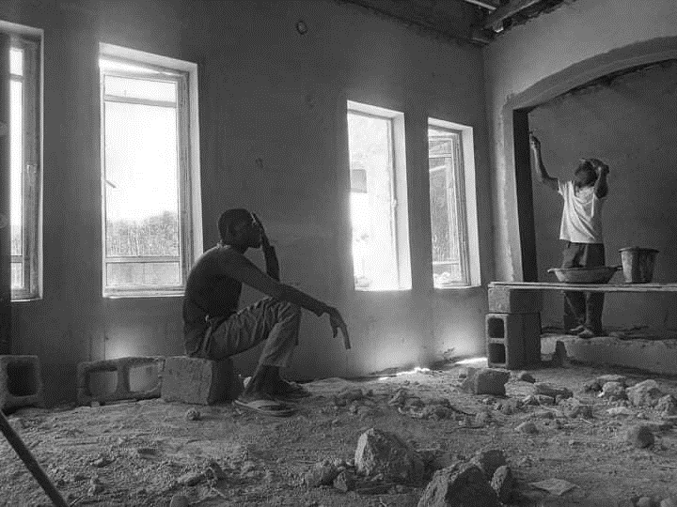
- Finished and Cleaned Up: Neatly trimmed corners and edges using a trowel or corner beads if necessary. Cleaned tools and equipment immediately after use to prevent plaster from hardening on them.

Plate 3.5: Mixed mortar and the plastering process
Source: Author’s work, 2024

CHAPTER FOUR

SUMMARY, CONCLUSION AND RECOMMENDATIONS

4.1 CHALLENGES ENCOUNTERED DURING SIWES
- The time frame set for the program is too short as some of the aspects of the program where not completed.
- Lack of Financial support from the company to aid transportation to and from training.
- Attentions are not given to the IT students by the workers it is learn if you want to learn or ask if you want to know.

4.2 SUMMARY
One would state that the discipline is the training of the mind and body towards effective performance. The Students Industrial Work Experience Scheme (SIWES) is more or less achieving this fit. As it further builds on the theoretical classrooms leaving a practical approach of the industry and commerce to supply of finished goods and services. This program has enabled the participating students to be practically involved in the day-by-day activities of the industries and commerce.
Emphasis in the observation of industrial safety rules and regulations, time critical operation and proper man-hand management, quality cortices, etc. are daily activity objective. All those aimed at the production of marketable goods and services in the world of work.
However, to consolidate on the gains of this Industrial Training Fund (ITF) higher institution coordinator on SIWES program should be allowed making some suggestion and recommendation.

4.3 CONCLUSION
SIWES programme is very vital student especially undergraduates, because I come to see the SIWES programme provide an application of the theoretical knowledge learned by student in school to practical or real work situation. Also, it is a medium where student from different higher institutions and department come together sharing idea there, by promoting an avenue for learning and them work.

4.4 RECOMMENDATIONS
Having being exposed to a bit of what entail working in an individual related to my course of study under SIWES programme I wish to make this recommendation
- Higher instruction of learning especially either institution and universities should establish link with comprise and establishment so as to provide space for student on industrial attachment, with the option of gaining employment in future, by doing so, it will go a long way in alleviating suffering and difficulties encountered by student in securing place for individual attachment.
- Student should put money as the primary aim of going SIWES programme, there is more to learn than Bain allowance.

REFERENCES
Chudley, R. (2005). Construction technology volume 2. Pearson Prentice Hall, New York.
Edward, B. (2003). The Effect of SIWES on a student, Federal Ministry of Works, Lagos. Nigeria.
Francis, K. (2012). Building Construction Illustration. (Fourth Edition). Wiley Publisher. ISBN-10: ‎ 9788126535637.

